CHEDBURGH PARISH COUNCIL
MINUTES FOR PARISH COUNCIL MEETING Monday 8th July 2024
Attendees: Cllr Sellars (Vice Chair), Cllr Rickard, Cllr McGhee, Cllr Simmons, Cllr Pettit, W S D Cllr Chester, Mrs F Betts (Clerk/RFO), Ben Wilding, Tariq Foley and Mrs L Williams
Apologies: Cllr Smith (Chair), SCCllr Soons and Mrs C Fitzgerald
NB Vice Chair Councillor Sellars chaired the meeting.
Item |  | Actions
1 | Welcome by Chair and apologies for absence.
2 | Public Participation  1. Ben Wilding and Tariq Foley from Suffolk Joint Emergency Planning Unit, Suffolk County Council made a presentation re Emergency Plans for villages. Following a lively discussion the Clerk asked for them to send her the templates so she could start working on a resilience plan for the village. W S Cllr Chester is keen to be involved and the Chair advised that the CCDRCC is informed at every step so they can be involved too.  2. The County Councillor’s Report had previously been circulated and is on the village website.  3.The District Councillor’s Report was received.  3:1 He discussed the dilapidated state of the former Marquis of Cornwallis pub. He asked that the Parish Council discuss its future plans. With the Community Asset having been removed the options are now to decide whether they wish it to remain a site for a future pub for the village (due to its current decrepitude this seems an unlikely scenario) or to allow for it under planning permission for change of status from business to residential. As there have been several incidences with vandalism resulting in the Police being called out it was unanimous to agree for this site to have its status changed. W S Cllr Chester will endeavour to contact the owner and start the process of change of use through West Suffolk Council and arrange for a working party to deal with this situation. The Parish Council are keen to be involved with any future plans.  3:2 Regarding the piece of PC owned land running along the A143 just right of the junction from the village onto the A143. (NB No one on the Council or the Clerk knew the PC owned this piece of land). The hedge is very overgrown Cllr Chester requests that this hedge and the grass verge below be cut back. Clerk to organise. Clerk to contact WS Parks department to add this area to next year’s cutting schedule  3:3 More estate agent boards have popped up around the village. This time at the entrance to Chestnut Crescent. Can the Clerk request these are removed. | Clerk  Cllr Chester  Clerk  Clerk  Clerk
3 | No Declaration of Councillors’ Interests received
4 | The Minutes of the Meetings held on 20th May 2024 were approved and signed as a true record
5 | Chair’s Report and progress reports for information  - Playground Revamp – the Council went out to look at the hedge running along the edge of the playing field with Chevington Road. The large willow on the CCDRCC’s side of the area has recently been pollarded. The ditch can clearly be seen full of organic debris but is dry. Four small, spindly ash trees can clearly be seen to be dead. The rest of the hedge has green leaves on and looks relatively well at the moment. The discussion concluded by asking the Clerk to contact the contractor to ask for a requote to remove the dead looking trees and to scrape out the ditch as much as they can down to 30-40 cms starting at the entrance to the Erskine Centre down towards the back of the field (just beside the boxed seat swing as seen on the photo). Clerk to advise CCDRCC of this decision.  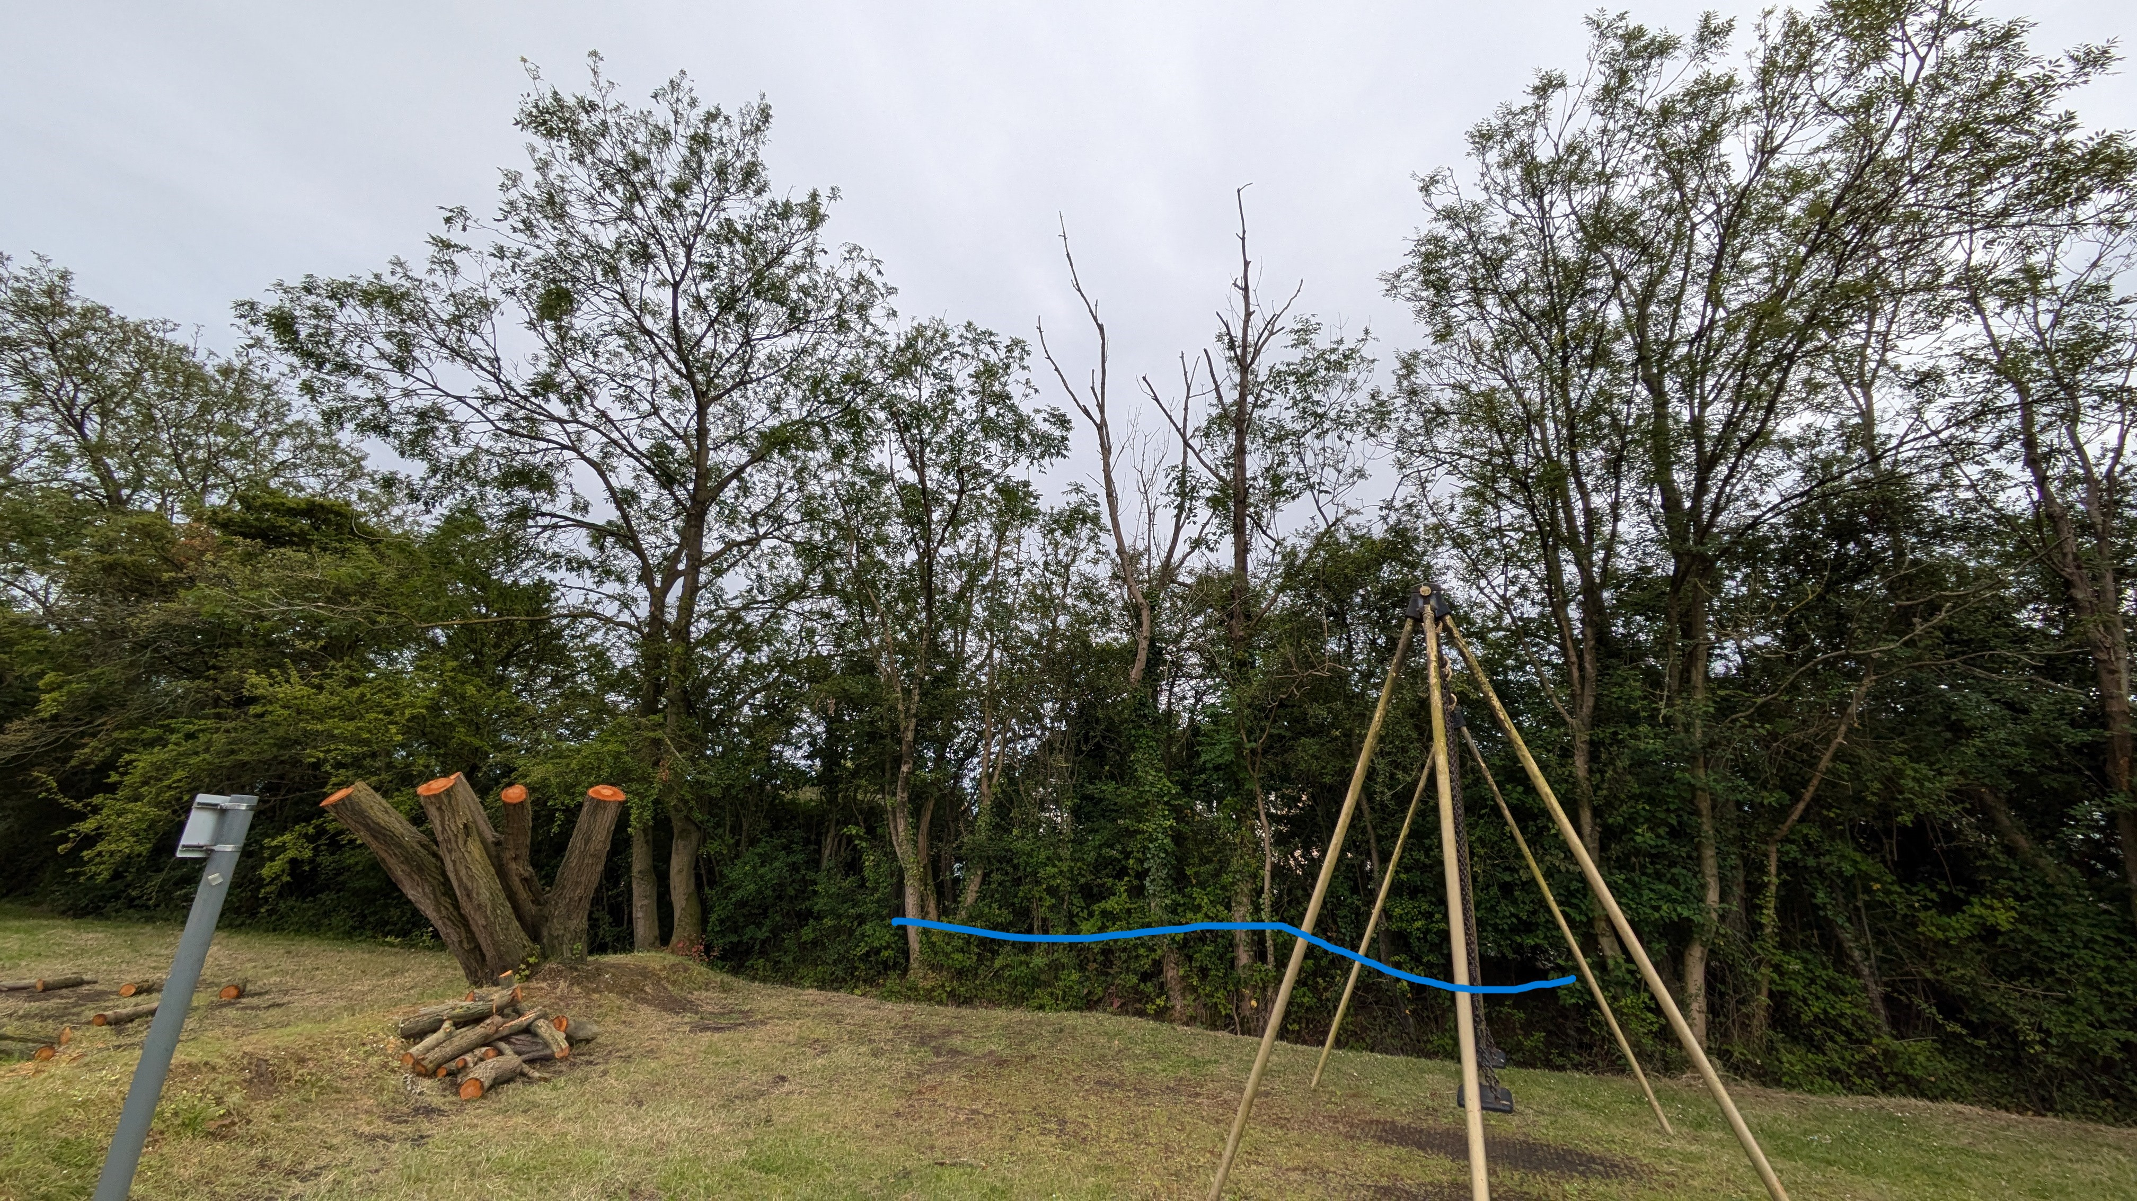  - Maintenance needed to benches by the bus stop on Chevington Road and near to the RAF memorial. Clerk to ask the Chair to contact his DIY man to look at this maintenance.  - Phone box ‘Info-point’ update. All books to be cleared and Clerk to investigate a printed info board to be made to fit the space within the box. The Information Space will be used on a seasonal basis. Seedlings and young plants during the spring and books/dvds during the Autumn and winter months. A parishioner has come forward as a co-ordinator. Clerk to liaise with this parishioner and to write up a risk assessment document. The purchase of various acrylic folders are to be organised by the Chair.  - The new notice board on Chevington Road is now up and being used by the Clerk. She wishes to thank the Parish Council for allowing her to have this new space which is much, much easier for her to use.  - The green squares of plastic grass that have appeared at the foot of some of the pieces of play equipment must be removed as they do not fit within the regulation H&S requirements. | Clerk  Cllr Smith  Clerk  Cllr Smith  Clerk
6 | Parish Councillors reports  - Cllr McGhee – VAS data  Cllr McGhee is trying to contact Horringer PC to ask for the numbers coming into their village from Bury St Edmunds. He also requests that the manhole cover, outside No 5 Bury Road which is very noisy and Cllr Rickard says she can hear it through her double-glazed windows too, be reported to Highways via their Reporting Tool.  - Cllr Sellars – Questionnaire update. Following a short discussion the Council agreed to pay for the full cost of printing and the online survey. Cllr Sellars proposed, Cllr Rickard seconded it and the following vote was unanimous for the PC to pay for this project. Clerk to seek funding via Cllr Chester’s locality budget. Questionnaire aiming to be distributed with September Benefice magazine.  - Cllr Rickard – Pantry. Only a small top up of supplies has been needed. It was thought that it may be that because heating bills are smaller at this time of year there wasn’t the requirement to use a good pantry as much as during the colder months. The Clerk was asked to contact Chevington Food bank coordinator to ask if they found the same. The Clerk (with consultation from Cllr Rickard) is to organise a fresh advertising campaign to reach out to families who may want to use this pantry.  - Cllr Simmons – Quiet Lane status for Queen’s Lane. This initiative was looked into several years ago but no further action was taken. Cllr Simmons believes that part of the lane fits the criteria. The cost is around £2500 and she will continue to investigate whether it is a viable and cost-effective option for the village.  - Proposal for a young Person’s sub-committee of the Parish Council. The Clerk will seek advice from SALC regarding this initiative.  - Siting of smelly dog poo bin on Chevington Road close to the bus stop and bench. In the hot weather the smell makes it very unpleasant to wait for the bus or to sit on the bench. Clerk to see if it can be moved further down to the road with WSC continuing to empty it.  - Cllr Pettit – Emergency/Resilience Plan. Cllr Pettit said that during Covid there was a WhatsApp group set up in the village by parishioners so they could help each other. She had found this very useful and she thought that a similar strategy could be set up within the emergency plan project. | Clerk  Clerk  Clerk  Cllr Simmons  Clerk  Clerk
   | Vehs from Haverhill
  Daily totals | 3,664
  Av speed | 28mph
  50th percentile | 27.9mph
  85th percentile | 33.4mph
  Max speed | 90mph Sunday (2250hrs)
7. | Planning Applications.  - DC/24/0853/TPO – 7 Stirling Close, Chedburgh. TPO 205 (1994) tree preservation order – one field maple (T10 on plan) cut back to boundary line (Consultation ends 25th July 2024) No objections  - DC/24/0832/TPO – 26 Majors Close, Chedburgh – TPO 147 (1970) one ash (on plan and within A1 on order) fell. Consultation ends 26th July 2024 No objections  - DC/23/1675/HH – 11 Majors Close, Chedburgh. Replace steps with ramp. No objections. (awaiting decision)
8 | To receive Financial Officer’s Report  1.Discuss and sign off all bank transactions since the last meeting (self governance)  NB By Virement means a payment not budgeted for (and does not come under a statutory power) but is a necessary expense for the running of the Council

Invoice detail | Details of Payee | Amount £ | Statute Power | BACS or Cheque NO
042 | Clerk May salary | 341.00 | S112 LGA 1972 | SO
043 | Clerk June salary | 341.00 | S112 LGA 1972 | S0
044 | Clerk overtime up to July 2024 | 164.73 | S112 LGA 1972 | BACS
045 | Clerk expenses | 18 | S112 LGA 1972 | BACS
2495 | CCDRCC hire of the hall 2 hours | 20 | S19 LGA 1972 | BACS
n/a | M Rogers wood for notice board | 453.16 | S112 LGA 1972 | BACS
5084 | McGregor Services cut edges and pathways to Mulberry Place/end of Silver Tree Way | 84 | Ss9-10 Open Spaces Act 1910 | BACS
101162 | Commemorative plaque | 8.98 | S112 LGA 1972 | BACS
5114 | McGregor Services cut trails at Mulberry Place | 84 | Ss9-10 Open Spaces Act 1910 | BACS
n/a | M Rogers to complete notice board | £542.84 | S112 LGA 1972 | BACS
 | All invoices discussed and payment agreed as per financial standing orders | Clerk
 | - Bank account balance as of 8th July 2024 is £7835.77
 | - 32 day Savings account balance as of 8th July 2024 is £26,112.43
9 | Clerk’s report and actions  1. Name for grass field at end of Silver Tree Way/Mulberry Place. Following a short discussion, it was decided that the Clerk should begin to call this area Mulberry Park.  2. Highways reports sent by a parishioner. Clerk to resend all items so that the PC has ownership of these reports. Clerk to contact Highways via its reporting tool regarding the grass verges at the entrance to the Erskine Centre running along Chevington Road towards Chevington.  3. Clerk has been in contact with Henry Smith Charity regarding footpaths and new gates. The actual formal footpath starts at the bottom of Factory Lane in Chevington towards Queens Lane in Chedburgh. The field with the new gates is NOT public right of way and the landowner can fence it how he needs it. A Suffolk Footpath Officer met with the landowner and is happy with the response he received.  4. Letters written and posted to households along Bury Road re ANPR device placement. Clerk waiting for all replies before she continues with this project. | Clerk
10 | Items for next agenda –  - Change of status for Marquis of Cornwallis pub  - Quiet Lanes  - Young Persons’s sub-committee of the Parish Council – research  - Questionnaire update  - Play area ditch/dead trees
 | Meeting ended at 21.47 hours

Signed by Chair …………………………………………… Date ………………………………..

